Time Series
Stationarity, ARIMA, Cointegration & Regime Awareness
Modelling Data That Evolves Through Time, Where Observations Are Not Independent
A Level 2 module in the Quantitative Finance Curriculum — revisited at Level 3
Covers: Stationarity · ACF/PACF · white noise · random walk · AR/MA/ARMA/ARIMA · unit roots / ADF test · cointegration (Engle-Granger) · error-correction models · VAR/VECM (awareness) · state-space models / Kalman filters (awareness) · HMM / regime switching (awareness) · structural breaks

Table of Contents
How to Use This Guide
What You Need to Know Before Starting
Understand Before Proceeding
Why It Matters
How This Connects to the Rest of the Curriculum
Glossary of Recurring Terms
Part 1 — Foundations: Stationarity, White Noise, and Random Walks
1.1 Stationarity
1.2 White Noise
1.3 The Random Walk
1.4 ACF and PACF: Reading the Fingerprint of a Series
Part 2 — Modelling Serial Dependence: AR, MA, ARMA, ARIMA
2.1 Autoregressive (AR) Models
2.2 Moving Average (MA) Models
2.3 ARMA and Model Identification
2.4 ARIMA: Handling Non-Stationarity via Differencing
Part 3 — Unit Roots and the Augmented Dickey-Fuller Test
3.1 Unit Roots and Spurious Regression
3.2 The Augmented Dickey-Fuller (ADF) Test
Part 4 — Cointegration and Pairs Trading
4.1 Correlation Is Not Cointegration
4.2 The Engle-Granger Two-Step Method
4.3 Error-Correction Models
Part 5 — Multivariate and Advanced Time Series (Awareness Level)
5.1 VAR and VECM
5.2 State-Space Models and Kalman Filters
5.3 HMMs and Regime Switching
5.4 Structural Breaks
Practical Exercise
Common Beginner Mistakes
Advanced Extensions
Professional Applications
Where to Go Next

How to Use This Guide
This document is a companion to Time Series, the second-level module in the quantitative finance curriculum that is revisited in more depth at Level 3. It covers methods for modelling data that evolves through time, where observations are not independent of one another — the single assumption that ordinary regression and most of classical statistics take for granted, and that almost all financial data violates by construction.
The module is self-contained: every concept is introduced from first principles, paired with a short runnable Python sketch, and illustrated with a chart wherever a picture makes the idea land faster than an equation. Read it start to finish if time series methods are new to you, or jump straight to the section you need.

What You Need to Know Before Starting
- Statistics — hypothesis testing, p-values, and confidence intervals, all of which are reused (with modification) throughout this module's tests.
- Regression — OLS mechanics and, especially, the autocorrelation and robust-standard-error material from that module's diagnostics section, since time series analysis is largely about taking serial dependence seriously rather than assuming it away.

Understand Before Proceeding
Prerequisite gate — Do not fit GARCH or regime-switching models before stationarity and the Augmented Dickey-Fuller (ADF) test are comfortable — Depth 2 or beyond. You must know whether your series needs differencing before any more advanced model is meaningful: fitting a sophisticated model on top of an unaddressed unit root does not fix the underlying problem, it just hides it behind more machinery.

Why It Matters
Almost all financial data is a time series. Prices, returns, spreads, volumes, and macroeconomic series are all observed sequentially, and successive observations are rarely independent of one another. Ignoring that dependence — treating a time series as if it were an unordered sample of independent draws — invalidates naive statistical tests and is a primary source of spurious backtest results: strategies that appear profitable in-sample purely because a test was applied to data it was never designed for.

How This Connects to the Rest of the Curriculum
- Research — cointegration is the statistical foundation of pairs trading and statistical arbitrage; almost every stat-arb strategy is, underneath, a claim that some combination of instruments is cointegrated.
- Development — time-series-aware train/test splitting and cross-validation must be built into any backtesting framework, or future information leaks into training folds and every subsequent result is unreliable.
- Trading — regime shifts (structural breaks) are why strategies that worked historically can suddenly stop working; a strategy calibrated on one regime carries no guarantee of working in the next.

Glossary of Recurring Terms
Stationarity — The property of a time series whose statistical characteristics — mean, variance, and autocorrelation structure — do not change over time.
White noise — A stationary series of uncorrelated, identically distributed random shocks with mean zero and constant variance — the simplest possible time series and the residual behaviour every good model aims to leave behind.
Random walk — A non-stationary series where each value equals the previous value plus a random, unpredictable shock, so today's level (not the change) carries no tendency to return to any fixed point.
ACF (autocorrelation function) — The correlation between a series and its own lagged values, plotted across lags — the standard tool for detecting and characterising serial dependence.
PACF (partial autocorrelation function) — The correlation between a series and a specific lag of itself, after removing the effect of all shorter lags — used alongside the ACF to identify AR and MA order.
AR (autoregressive) model — A model in which the current value is a linear function of its own past values plus noise.
MA (moving average) model — A model in which the current value is a linear function of past forecast errors (shocks) plus noise.
ARMA / ARIMA — ARMA combines AR and MA components for a stationary series; ARIMA adds an Integration (differencing) step to first handle a non-stationary series before the ARMA structure is fitted.
Unit root — A mathematical property of a non-stationary series (most commonly a random walk) that causes shocks to have a permanent, rather than fading, effect on its level.
ADF test (Augmented Dickey-Fuller) — A hypothesis test whose null hypothesis is that a series has a unit root (is non-stationary); rejecting the null is evidence the series is stationary.
Cointegration — A property of two or more non-stationary series that individually wander but share a common stochastic trend, so that some specific linear combination of them is itself stationary.
Engle-Granger method — A two-step procedure for testing cointegration: regress one series on the other(s), then test the regression's residuals for a unit root.
Error-correction model (ECM) — A model for cointegrated series that combines short-run dynamics with a term that pulls the system back toward its long-run cointegrating relationship whenever it drifts away.
VAR / VECM — Vector Autoregression models several time series jointly, each as a function of lagged values of all the series; a Vector Error-Correction Model is the VAR analogue for cointegrated series.
State-space model / Kalman filter — A framework that models an unobserved ("hidden") state evolving over time, with the Kalman filter providing the optimal recursive procedure for estimating that hidden state from noisy observations.
HMM (Hidden Markov Model) / regime switching — A model in which an unobserved discrete state (a "regime") governs the statistical behaviour of an observed series, with the regime itself evolving according to a Markov process.
Structural break — A point in time at which the underlying data-generating process changes — a shift in mean, variance, or relationship — rather than a temporary fluctuation within an unchanged process.

Part 1 — Foundations: Stationarity, White Noise, and Random Walks
Every time series technique in this module rests on a single question, asked and answered first: is this series stationary? This part defines stationarity, introduces the two reference processes — white noise and the random walk — that anchor the intuition for what stationary and non-stationary behaviour actually look like, and introduces the ACF and PACF as the standard diagnostic tools for reading a series' serial structure.

1.1 Stationarity
A time series is (weakly, or covariance) stationary if its mean, variance, and autocovariance structure do not depend on time — formally, for a series yₜ:
E[yₜ] = μ (constant) Var(yₜ) = σ² (constant) Cov(yₜ, yₜ₋ₖ) depends only on k, not on t
Stationarity matters because almost every classical time-series model — AR, MA, ARMA — and every inferential result built on top of them assumes it. A model fit to a non-stationary series is not simply less accurate; its estimated parameters and standard errors can be entirely meaningless, since the quantities the model is estimating (a constant mean, a constant variance) don't actually exist in the data.
Tip — Strict stationarity requires the entire probability distribution to be time-invariant, not just its first two moments. In practice, almost all applied time series work uses the weaker (covariance) definition given above, which is sufficient for the models covered in this module.

1.2 White Noise
White noise is the simplest stationary process: a sequence of uncorrelated shocks with constant mean (usually zero) and constant variance.
εₜ ~ i.i.d.(0, σ²), Cov(εₜ, εₜ₋ₖ) = 0 for all k ≠ 0
White noise is unpredictable by construction — no model can improve on simply forecasting its mean — which makes it the target behaviour for residuals: if a fitted AR, MA, or ARIMA model has genuinely captured all the serial structure in a series, what remains should look like white noise. Section 1.4's ACF is the standard tool for checking this.

1.3 The Random Walk
A random walk is the canonical non-stationary process: each value equals the previous value plus a white-noise shock.
yₜ = yₜ₋₁ + εₜ (with drift: yₜ = c + yₜ₋₁ + εₜ)
A random walk's variance grows linearly with time (Var(yₜ) = tσ²), so it has no fixed level to revert to and no constant variance — it fails both conditions for stationarity. This is not a pathological edge case: log asset prices are, to a first approximation, well described by a random walk (with drift), which is precisely why price levels themselves are treated as non-stationary throughout this module, while returns (the first difference of log price) are treated as approximately stationary.
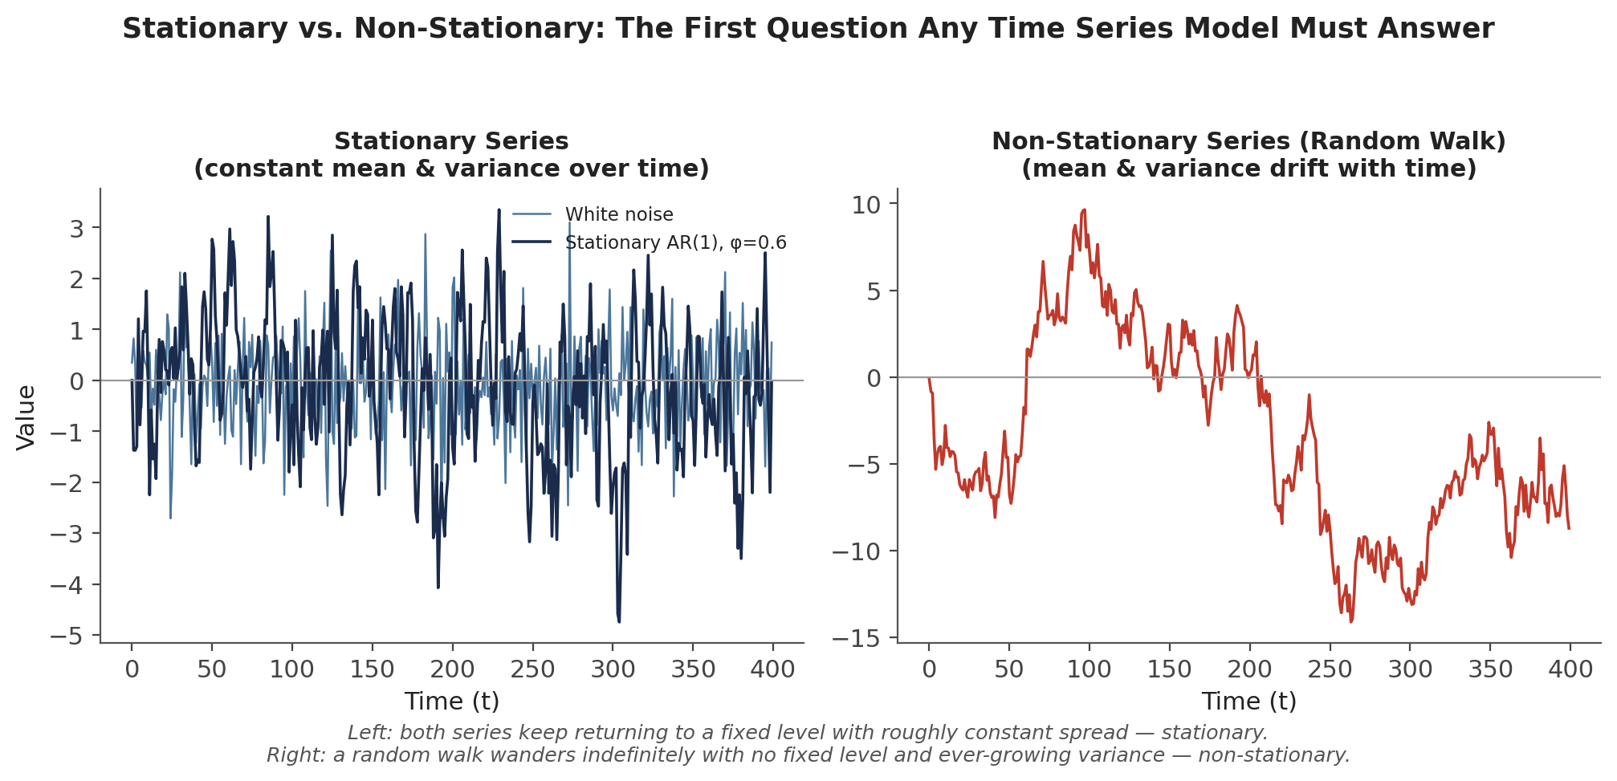
Figure 1.1 — A stationary series (white noise and a stationary AR(1)) keeps returning to a fixed level with roughly constant spread. A random walk wanders indefinitely, with no fixed level and ever-growing variance.
import numpy as np

eps = np.random.normal(0, 1, 500) # white noise
random_walk = np.cumsum(eps) # non-stationary: cumulative sum of shocks

1.4 ACF and PACF: Reading the Fingerprint of a Series
The autocorrelation function (ACF) measures how correlated a series is with its own past values at each lag k:
ACF(k) = Corr(yₜ, yₜ₋ₖ)
The partial autocorrelation function (PACF) measures the same thing, but strips out the indirect correlation transmitted through the intervening lags — the correlation between yₜ and yₜ₋ₖ that is not already explained by yₜ₋₁ through yₜ₋ₖ₊₁. Plotted together across a range of lags, with a shaded band marking the threshold for statistical significance, the ACF and PACF are the standard diagnostic pair for identifying what kind of model — AR, MA, or a mix of both — best describes a series' serial structure, exactly the identification step used in Part 2.
from statsmodels.graphics.tsaplots import plot_acf, plot_pacf

plot_acf(series, lags=20)
plot_pacf(series, lags=20)

Part 2 — Modelling Serial Dependence: AR, MA, ARMA, ARIMA
This part introduces the classical linear time series models built from the two basic ingredients — dependence on past values (AR) and dependence on past shocks (MA) — and the standard workflow for identifying, fitting, and validating them.

2.1 Autoregressive (AR) Models
An AR(p) model expresses the current value as a linear function of its own previous p values, plus white noise:
yₜ = c + φ₁yₜ₋₁ + φ₂yₜ₋₂ + … + φₚyₜ₋ₚ + εₜ
Intuitively, an AR model says the series has memory: today's value is pulled toward a combination of recent past values, with the φ coefficients determining how strongly and how far back that pull extends. For the process to be stationary, the φ coefficients must satisfy a boundedness condition (informally, the 'roots' of the model must lie outside the unit circle) — an AR(1) with |φ₁| < 1 is stationary and mean-reverting; |φ₁| = 1 is exactly the random walk from Section 1.3; |φ₁| > 1 explodes.

2.2 Moving Average (MA) Models
An MA(q) model expresses the current value as a linear function of the current and past q forecast errors (shocks), rather than past levels:
yₜ = c + εₜ + θ₁εₜ₋₁ + θ₂εₜ₋₂ + … + θ_qεₜ₋q
An MA process is always stationary regardless of the θ coefficients (a finite sum of a finite number of white-noise terms cannot have unbounded variance), which is one of the properties that makes the ACF/PACF signature in Section 2.3 so useful for telling AR and MA structure apart: an MA(q) process's autocorrelation drops to exactly zero after lag q, since observations more than q periods apart share no common shock terms at all.

2.3 ARMA and Model Identification
ARMA(p, q) combines both components into a single model:
yₜ = c + φ₁yₜ₋₁ + … + φₚyₜ₋ₚ + εₜ + θ₁εₜ₋₁ + … + θ_qεₜ₋q
Choosing p and q is the model identification step, and the ACF/PACF pair from Section 1.4 is the classical tool for it, following a simple mirror-image rule:
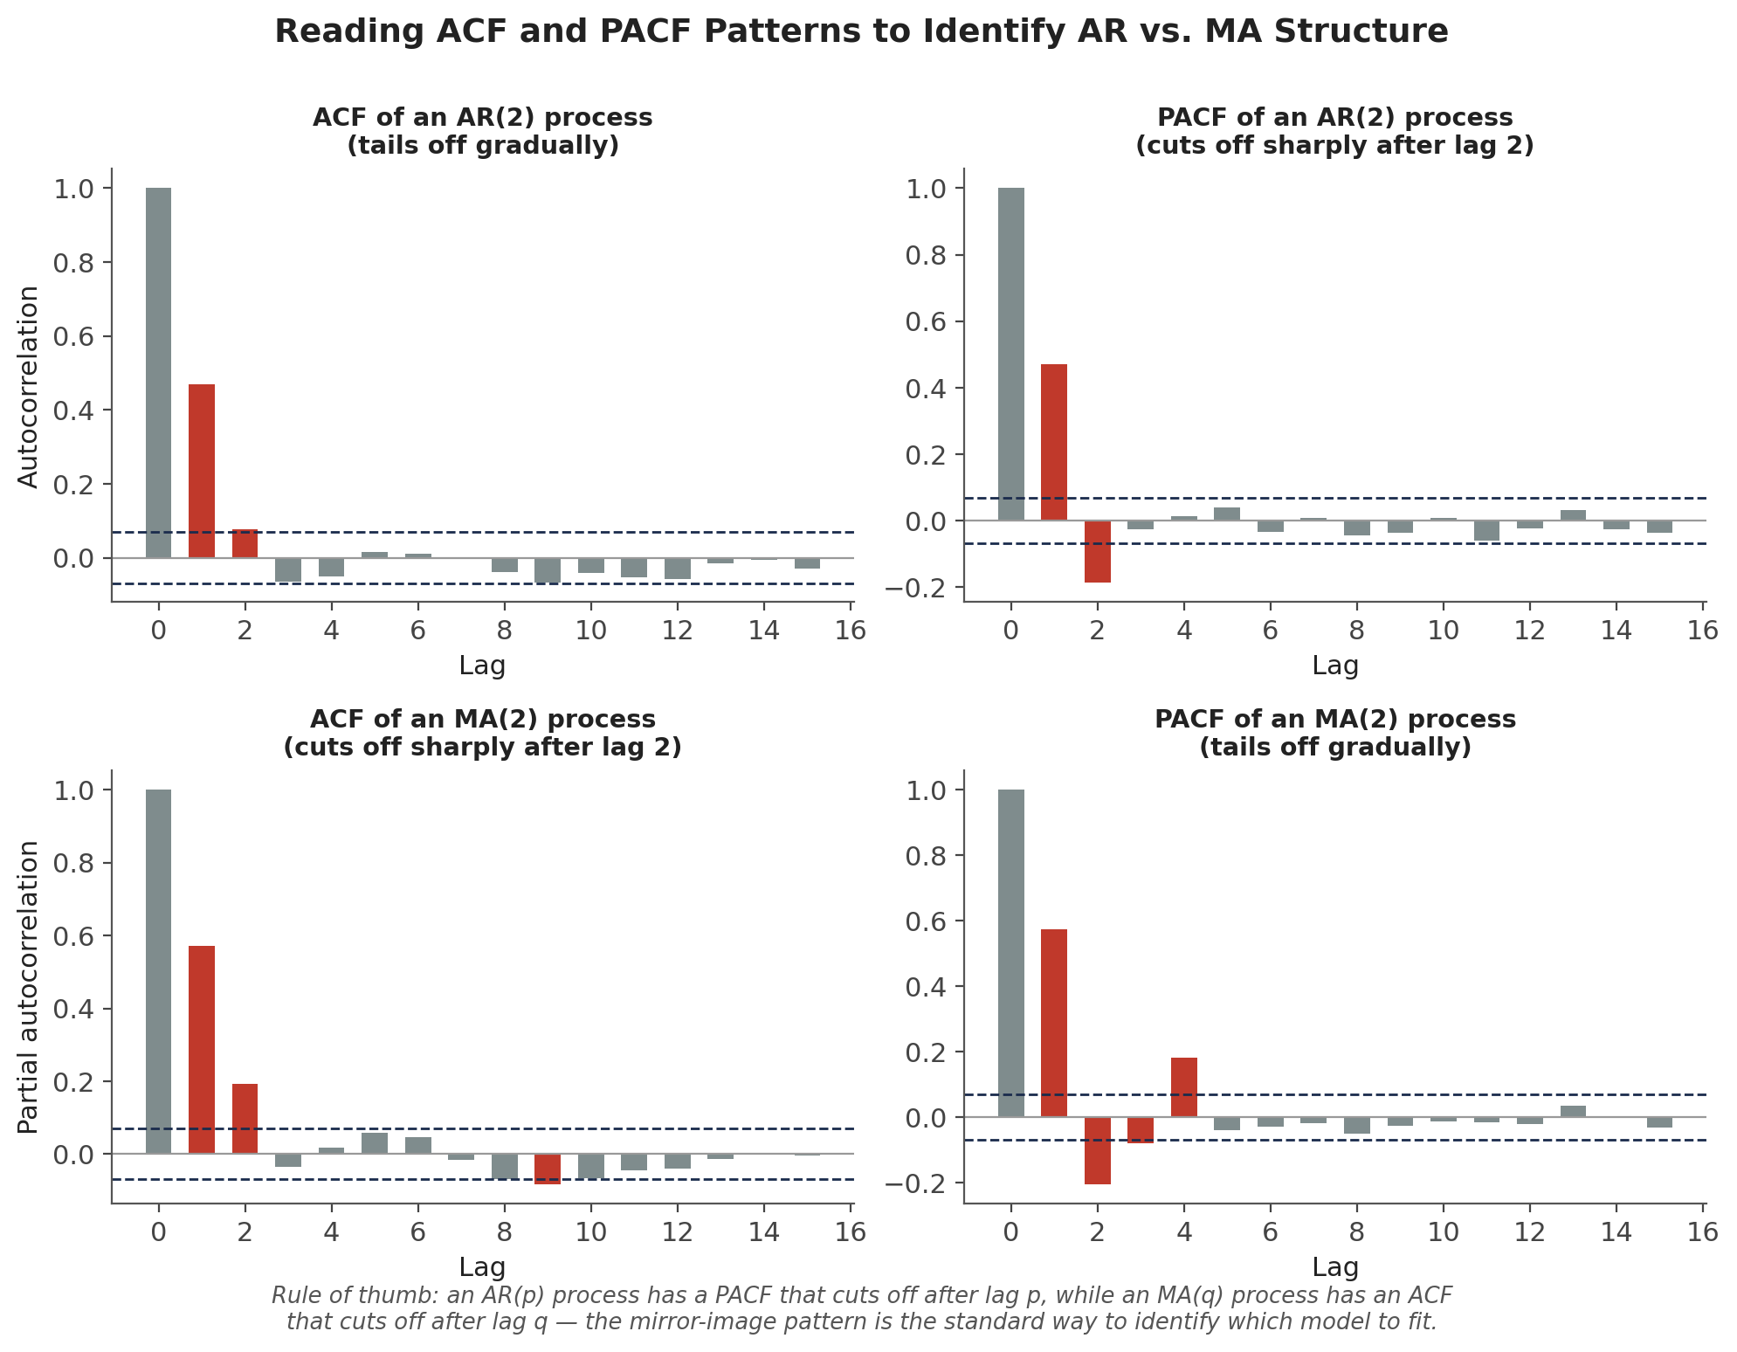
Figure 2.1 — An AR(p) process has a PACF that cuts off sharply after lag p while its ACF tails off gradually; an MA(q) process shows the mirror image — ACF cuts off after lag q, PACF tails off gradually. A process with both AR and MA components (ARMA) typically shows gradual tailing-off in both.
In practice, information criteria (AIC, BIC) computed across a grid of candidate (p, q) pairs are used alongside, or instead of, visual ACF/PACF inspection to make the final order selection more systematic:
from statsmodels.tsa.arima.model import ARIMA

model = ARIMA(series, order=(2, 0, 0)) # AR(2)
fit = model.fit()
print(fit.aic, fit.bic)

2.4 ARIMA: Handling Non-Stationarity via Differencing
ARIMA(p, d, q) adds a third parameter, d, specifying how many times the raw series must be differenced before it becomes stationary enough for the ARMA(p, q) machinery above to apply:
Δᵈyₜ = (1 − L)ᵈ yₜ is modelled as ARMA(p, q), where L is the lag operator, Lyₜ = yₜ₋₁
For most financial price series, d = 1 (a single first-difference, or equivalently working with returns rather than price levels) is sufficient to achieve stationarity — differencing again beyond what stationarity requires tends to introduce unnecessary noise and negative autocorrelation. Determining d is exactly the job of the unit-root test covered next.
from statsmodels.tsa.arima.model import ARIMA

model = ARIMA(price_level, order=(1, 1, 1)) # ARIMA(1,1,1): differenced once, then ARMA(1,1)
fit = model.fit()
forecast = fit.forecast(steps=10)

Part 3 — Unit Roots and the Augmented Dickey-Fuller Test
This part makes precise the distinction between stationary and non-stationary behaviour introduced in Part 1, and covers the standard formal test for telling them apart — the single most important preliminary check before fitting any of the models above.

3.1 Unit Roots and Spurious Regression
A series has a unit root when a shock to it has a permanent rather than fading effect on its level — the random walk of Section 1.3 is the textbook example. Running standard regressions or correlations between two series that each have a unit root, without addressing the non-stationarity first, risks spurious regression: two entirely unrelated random walks will frequently show a highly statistically significant relationship (a large t-statistic, an impressive R²) purely because both are trending, not because either genuinely explains the other.
Common mistake — Confusing correlation with cointegration. Two non-stationary series can appear strongly related in a naive regression purely as a spurious-regression artefact of shared non-stationarity, with no genuine long-run relationship at all. Section 4.1 covers the specific, much stronger condition — cointegration — that a pair of series must satisfy before that apparent relationship can be trusted for trading purposes.

3.2 The Augmented Dickey-Fuller (ADF) Test
The Augmented Dickey-Fuller test formalises the stationary-vs-unit-root question. Its null hypothesis is that the series has a unit root (is non-stationary); rejecting the null (a sufficiently negative test statistic, or equivalently a small p-value) is evidence the series is stationary:
H₀: series has a unit root (non-stationary) H₁: series is stationary
The standard workflow is to run the ADF test on the raw series, and if it fails to reject the unit-root null, difference the series and test again — repeating until the test rejects, at which point the number of differences applied is exactly the d parameter for ARIMA:
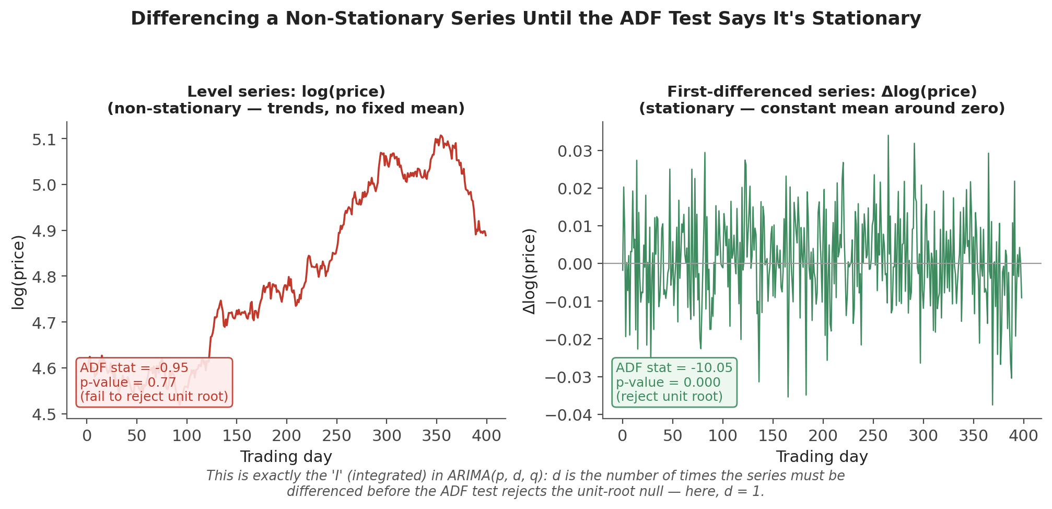
Figure 3.1 — The level series (log price) fails to reject the ADF null (p ≈ 0.77, consistent with a unit root); the first-differenced series (returns) rejects it decisively (p ≈ 0.00). One difference is enough here — this is exactly why returns, not price levels, are the standard object of time-series analysis in finance.
from statsmodels.tsa.stattools import adfuller

adf_stat, p_value, *_ = adfuller(log_price, autolag='AIC')
if p_value > 0.05:
log_price_diff = log_price.diff().dropna() # difference and re-test
adf_stat, p_value, *_ = adfuller(log_price_diff, autolag='AIC')
Tip — A high p-value on the ADF test is not proof a series is non-stationary — it is a failure to reject the null, which is a weaker statement. ADF is also known to have relatively low power against near-unit-root but technically-stationary alternatives (a series that mean-reverts extremely slowly), so a borderline result is worth treating cautiously rather than as a definitive verdict either way.

Part 4 — Cointegration and Pairs Trading
This part covers the statistical foundation of pairs trading and statistical arbitrage: the specific, stronger condition two non-stationary series must satisfy for a trading relationship between them to be more than a spurious-regression artefact.

4.1 Correlation Is Not Cointegration
Two series are correlated if their changes tend to move together. Two series are cointegrated if, despite each individually being non-stationary (a unit root, a random walk), some specific linear combination of them is stationary — meaning they share a common stochastic trend and the gap between them (that linear combination) is mean-reverting rather than free to drift apart indefinitely. These are different properties, and neither implies the other: highly correlated return series can still belong to prices that drift permanently apart, while genuinely cointegrated series can have relatively modest return correlation while their price spread is tightly anchored.
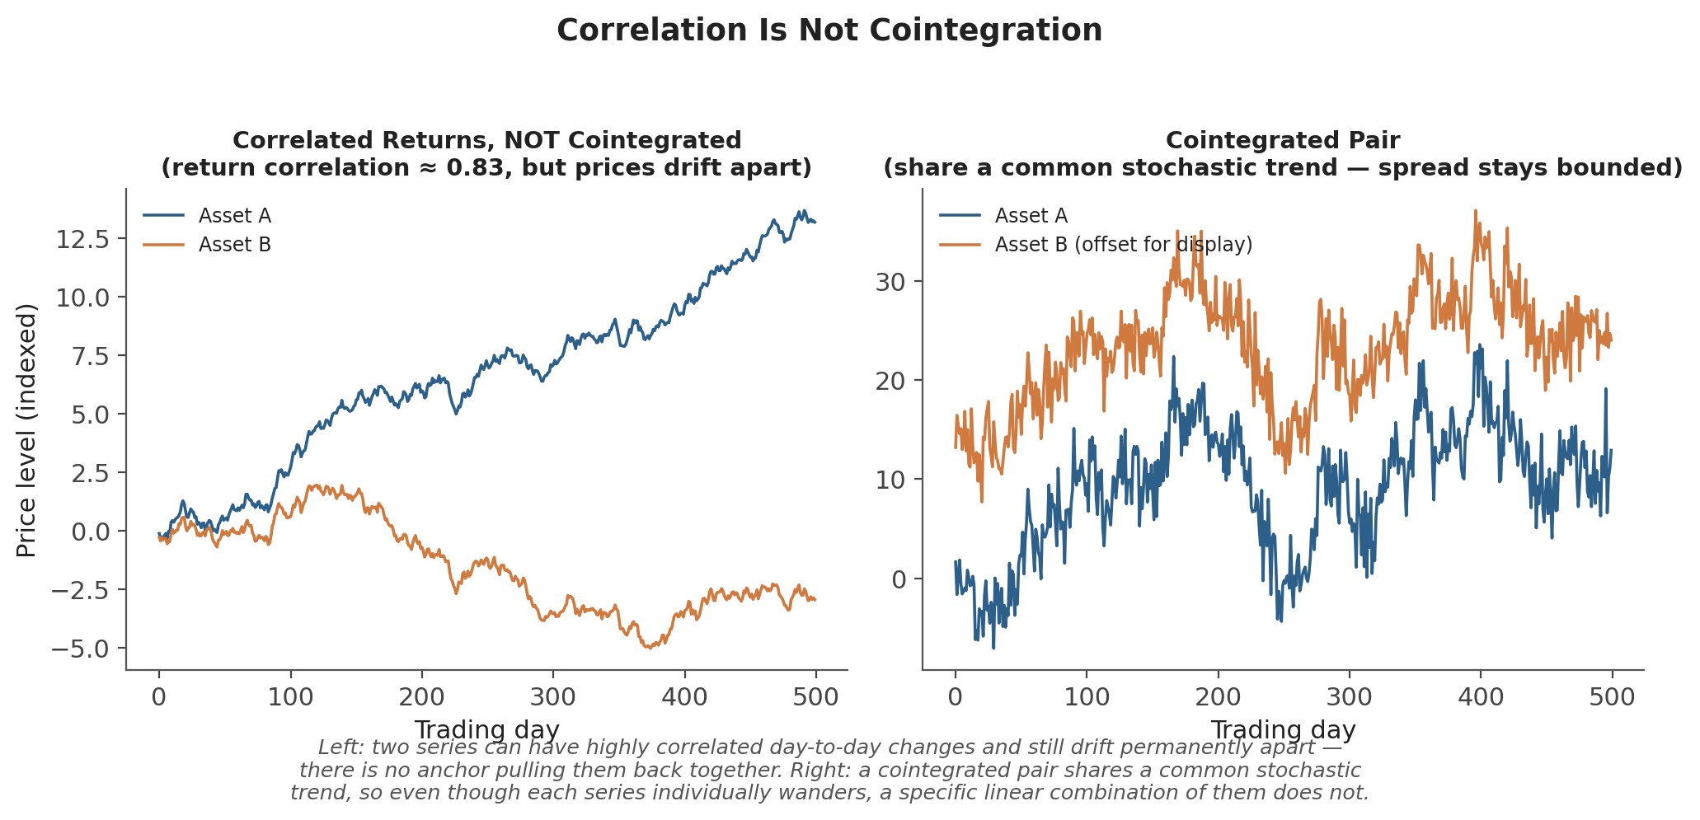
Figure 4.1 — Left: two series with strongly correlated daily changes can still drift permanently apart — there is no force anchoring them together. Right: a cointegrated pair shares a common stochastic trend, so a specific linear combination of the two — the spread — remains stationary even though each series individually wanders.
Common mistake — Confusing correlation with cointegration. Correlated series can still drift apart permanently. A pairs trade built on correlation alone has no statistical guarantee that the spread will ever revert — cointegration, tested formally as in Section 4.2, is the actual condition that justifies betting on reversion.

4.2 The Engle-Granger Two-Step Method
The Engle-Granger method tests for cointegration between two series in two steps. First, regress one series on the other using OLS to estimate the cointegrating relationship (the hedge ratio):
Step 1: Aₜ = c + β Bₜ + uₜ (OLS regression)
Second, test the residuals uₜ = Aₜ − c − βBₜ for a unit root using the ADF test from Section 3.2. If the residuals reject the unit-root null — i.e., the residual spread is itself stationary — then A and B are cointegrated with cointegrating vector (1, −β):
Step 2: ADF test on ûₜ. Reject unit root ⟹ A and B are cointegrated.
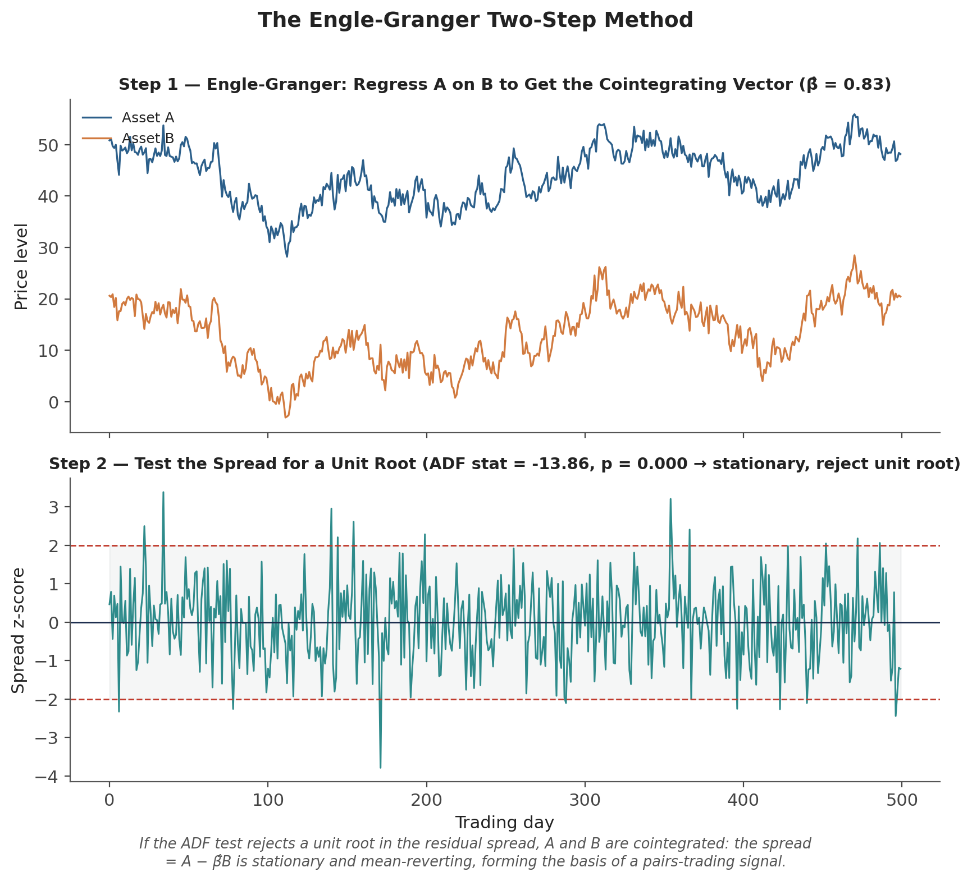
Figure 4.2 — Step 1 regresses Asset A on Asset B to estimate the cointegrating vector (hedge ratio β̂). Step 2 tests the resulting spread for a unit root; rejecting it confirms cointegration and produces a mean-reverting z-scored spread — the direct basis for a pairs-trading entry/exit signal.
from statsmodels.tsa.stattools import coint

coint_stat, p_value, crit_values = coint(asset_a, asset_b)
if p_value < 0.05:
print('Reject null of no cointegration — series are cointegrated')
A caveat on direction — Engle-Granger's two-step test is not symmetric: regressing A on B and testing the residuals can give a slightly different result from regressing B on A, especially in finite samples. For more than two series, or when this asymmetry matters, the Johansen test (which tests for cointegration within a VECM framework, Section 5.1) is the more robust standard alternative.

4.3 Error-Correction Models
If two series are cointegrated, the Granger Representation Theorem guarantees they can be described by an error-correction model (ECM): a model of short-run changes in one series that includes a term pulling the system back toward the long-run cointegrating relationship whenever it has drifted away from it.
ΔAₜ = α (Aₜ₋₁ − βBₜ₋₁) + Σ γᵢ ΔAₜ₋ᵢ + Σ δᵢ ΔBₜ₋ᵢ + εₜ
The term (Aₜ₋₁ − βBₜ₋₁) is the previous period's deviation from the long-run equilibrium (the lagged spread); α, the error-correction coefficient, measures how quickly that deviation is corrected — a negative α (as required for stability) means a positive spread today predicts a negative change in A tomorrow, pulling the spread back down. This single coefficient is, in effect, a direct estimate of the mean-reversion speed a pairs-trading strategy is relying on.

Part 5 — Multivariate and Advanced Time Series (Awareness Level)
The four topics in this part are covered at awareness level: enough to recognise what each method is for, when it would be reached for, and how it relates to the foundations already covered, without full derivation or hands-on implementation. Full treatment of Kalman filters and HMMs in particular is deferred to Level 5–6, per the Advanced Extensions note at the end of this module.

5.1 VAR and VECM
Vector Autoregression (VAR) generalises the AR model of Section 2.1 to several time series jointly, modelling each series as a function of lagged values of itself and every other series in the system:
yₜ = c + Φ₁yₜ₋₁ + Φ₂yₜ₋₂ + … + Φₚyₜ₋ₚ + εₜ (yₜ a vector of several series, Φᵢ matrices)
VAR treats all included series symmetrically, without assuming any particular direction of causality, which makes it a natural tool for studying how shocks to one series (e.g. an interest rate) propagate to others (e.g. equity returns, currency levels) over time. A Vector Error-Correction Model (VECM) is the VAR analogue for a system of cointegrated series, combining VAR's multivariate dynamics with the equilibrium-correcting term from Section 4.3, generalised to more than two series via the Johansen procedure.

5.2 State-Space Models and Kalman Filters
A state-space model separates a system into an unobserved ("hidden") state that evolves over time and a noisy observation process that depends on that hidden state:
State equation: xₜ = F xₜ₋₁ + wₜ
Observation equation: yₜ = H xₜ + vₜ
The Kalman filter is the optimal recursive algorithm for estimating the hidden state xₜ from a stream of noisy observations yₜ, updating its estimate one observation at a time rather than re-solving the whole problem from scratch. In quant finance, the most common application is treating a time-varying hedge ratio or beta as the hidden state: instead of the discrete rolling-window re-estimation covered in the Regression module, a Kalman filter produces a smoothly updating estimate that adapts to every new observation immediately.

5.3 HMMs and Regime Switching
A Hidden Markov Model assumes an observed series' statistical behaviour (its mean, its volatility) is governed by an unobserved discrete state — a regime — which itself evolves according to a Markov process (the probability of switching regimes next period depends only on the current regime, not the full history).
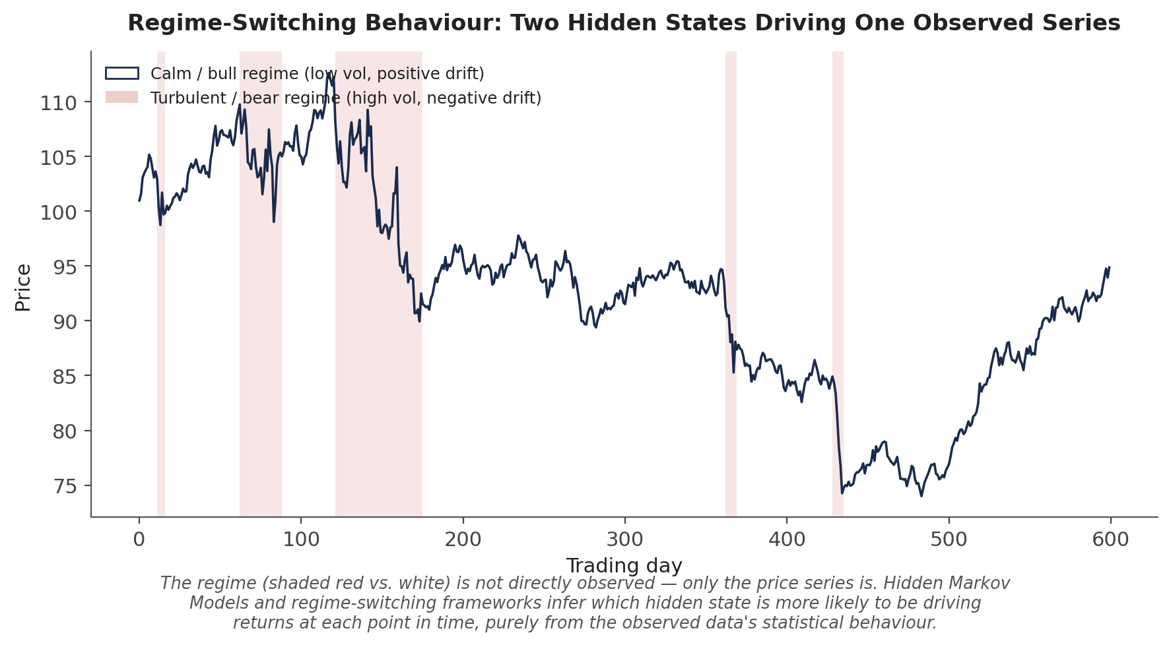
Figure 5.1 — A single observed price series (dark line) is secretly generated by two hidden regimes: a calm/bull state (low volatility, positive drift) and a turbulent/bear state (high volatility, negative drift, shaded red). HMMs and regime-switching models infer which state is more likely to be active at each point purely from the observed series' statistical behaviour.
Regime-switching frameworks are the natural response to a market behaviour that classical single-regime models (a single AR or ARMA process fit over the whole sample) cannot capture: volatility clustering and abrupt shifts in mean or variance that look less like noise around a stable process and more like the process itself changing.

5.4 Structural Breaks
A structural break is a point in time where the underlying data-generating process changes permanently — as opposed to a regime switch (Section 5.3), which is typically modelled as a temporary, recurring state that the system can switch back out of. Formal tests (the Chow test, for a known candidate break date; the CUSUM test, for detecting a break at an unknown date) exist, but the practical implication for trading is often more important than the formal statistical machinery:
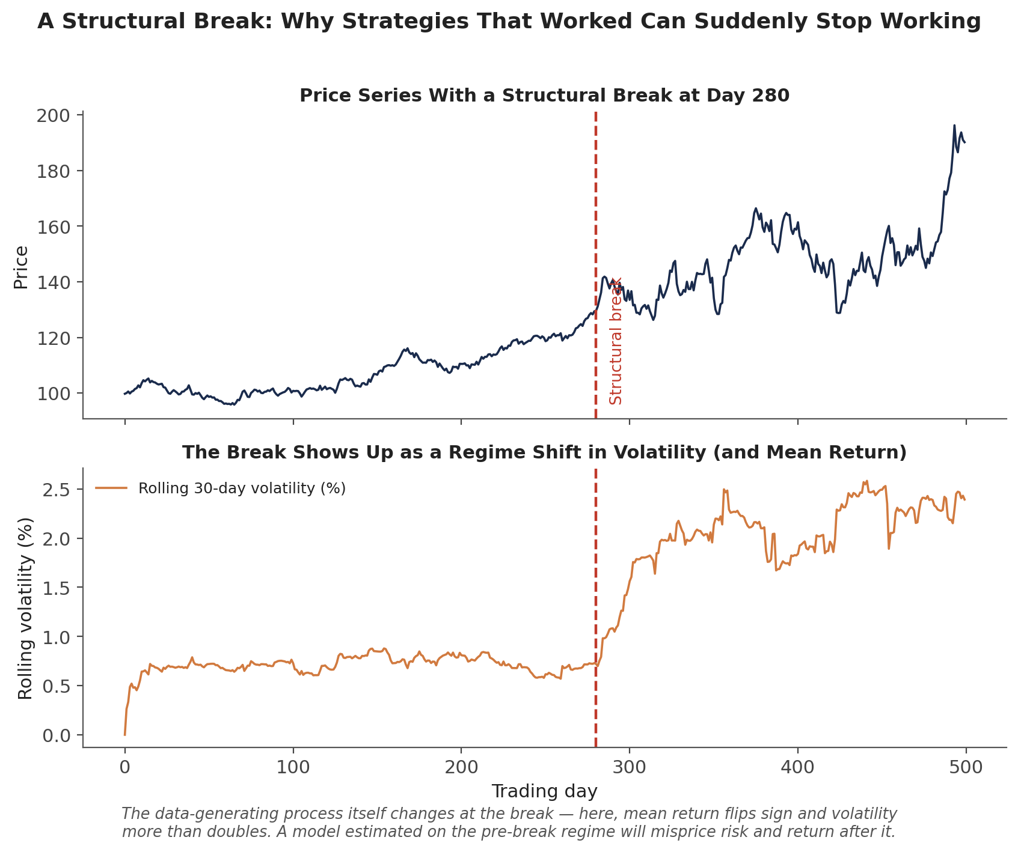
Figure 5.2 — A structural break at day 280: mean return flips sign and volatility more than doubles. A model — or a trading strategy — calibrated on the pre-break data has no statistical basis for its parameters to remain valid afterward.
Why this matters for backtesting — A strategy backtested entirely within one regime, with no structural break in its sample period, provides no evidence about how it will behave after the next one. This is precisely why time-series-aware, walk-forward validation (Section on Common Beginner Mistakes below) matters more in finance than in most other applied domains — the underlying process is not guaranteed to stay the same.

Practical Exercise
Using daily price data for two historically correlated assets (for example, two stocks in the same sector, or a stock and its sector ETF):
- Plot both price series and informally assess whether each individually looks stationary or non-stationary (Section 1.1).
- Run the ADF test on each series' level and, separately, on its first difference (Section 3.2) — confirm both price series are non-stationary in levels and stationary once differenced.
- Test the two series for cointegration using the Engle-Granger method (Section 4.2): regress one on the other, then run the ADF test on the regression residuals.
- If the pair is cointegrated, construct the spread using the estimated hedge ratio, convert it to a z-score, and build a simple mean-reversion signal — for example, go long the spread when its z-score falls below −2 and short it when the z-score rises above +2.
- Check the spread's own ACF (Section 1.4) to confirm it behaves like a mean-reverting stationary series rather than showing the slowly-decaying autocorrelation typical of a near-unit-root process.
from statsmodels.tsa.stattools import adfuller, coint
import statsmodels.api as sm

coint_stat, p_value, _ = coint(price_a, price_b)

X = sm.add_constant(price_b)
hedge_ratio = sm.OLS(price_a, X).fit().params[1]
spread = price_a - hedge_ratio * price_b
z_score = (spread - spread.mean()) / spread.std()

signal = pd.Series(0, index=z_score.index)
signal[z_score < -2] = 1 # long the spread
signal[z_score > 2] = -1 # short the spread

Common Beginner Mistakes
Common mistake — Using standard (non-time-series-aware) k-fold cross-validation. Randomly shuffling observations into folds, as standard k-fold CV does, allows future information to leak into training folds whenever a later observation ends up training a model that is then tested on an earlier one. Time-series cross-validation (walk-forward or expanding-window validation, where each test fold strictly follows its training data in time) is the required alternative for any time-dependent data.
Common mistake — Confusing correlation with cointegration. Correlated series can still drift apart permanently — a pairs trade built on correlation alone has no statistical guarantee that the two legs will ever come back together, whereas cointegration, formally tested (Section 4.2), is the specific property that justifies expecting reversion.

Advanced Extensions
Kalman filters (Section 5.2) extend naturally into dynamic hedge-ratio estimation — a continuously updating alternative to the discrete rolling-window regression covered in the Regression module — and into broader dynamic linear model frameworks used throughout macro and fixed-income research. Hidden Markov Models (Section 5.3) extend into fuller regime-detection systems that can drive dynamic position sizing or strategy switching, conditioning risk exposure on the currently inferred market regime rather than treating all periods identically. Both of these are deferred to full treatment at Level 5–6 of the curriculum, per the prerequisite gate noted at the start of this module: the mechanics of stationarity testing and unit roots need to be second nature first, since every one of these advanced models still depends on correctly identifying whether, and how, a series needs to be transformed before it is modelled.

Professional Applications
- Pairs trading — the Engle-Granger or Johansen cointegration test is the standard statistical gate a candidate pair must pass before a mean-reversion spread strategy is built on it.
- Statistical arbitrage — larger-scale stat-arb books generalise the two-asset pairs-trading idea to baskets of cointegrated instruments, often using VECM-based frameworks (Section 5.1) to manage the resulting multivariate error-correction dynamics.
- Regime-aware strategy switching — desks that condition position sizing, risk limits, or strategy selection on an inferred market regime are directly applying the HMM / regime-switching ideas of Section 5.3, typically alongside explicit monitoring for the structural breaks covered in Section 5.4.

Where to Go Next
This module gives you the vocabulary and diagnostic habits — stationarity, ACF/PACF, unit roots, and cointegration — that underpin every more advanced time-series technique in the curriculum. Nearly everything that follows involving sequential or dependent data will assume these checks have already been run, rather than re-deriving them.

Suggested paths depending on your focus
- Heading into research: revisit the Regression module's pairs-trading section with a formal Engle-Granger or Johansen cointegration test in hand, rather than relying on correlation alone to justify a hedge ratio.
- Heading into development: build time-series-aware (walk-forward) cross-validation into any shared backtesting utility, so it is the default rather than something each researcher must remember to implement individually.
- Heading into trading: focus on Section 5.4 — build monitoring for structural breaks (rolling mean/variance shifts) into live strategies, so a regime change is flagged rather than silently eroding performance.

